|  |
| --- |
| Lab 10 |

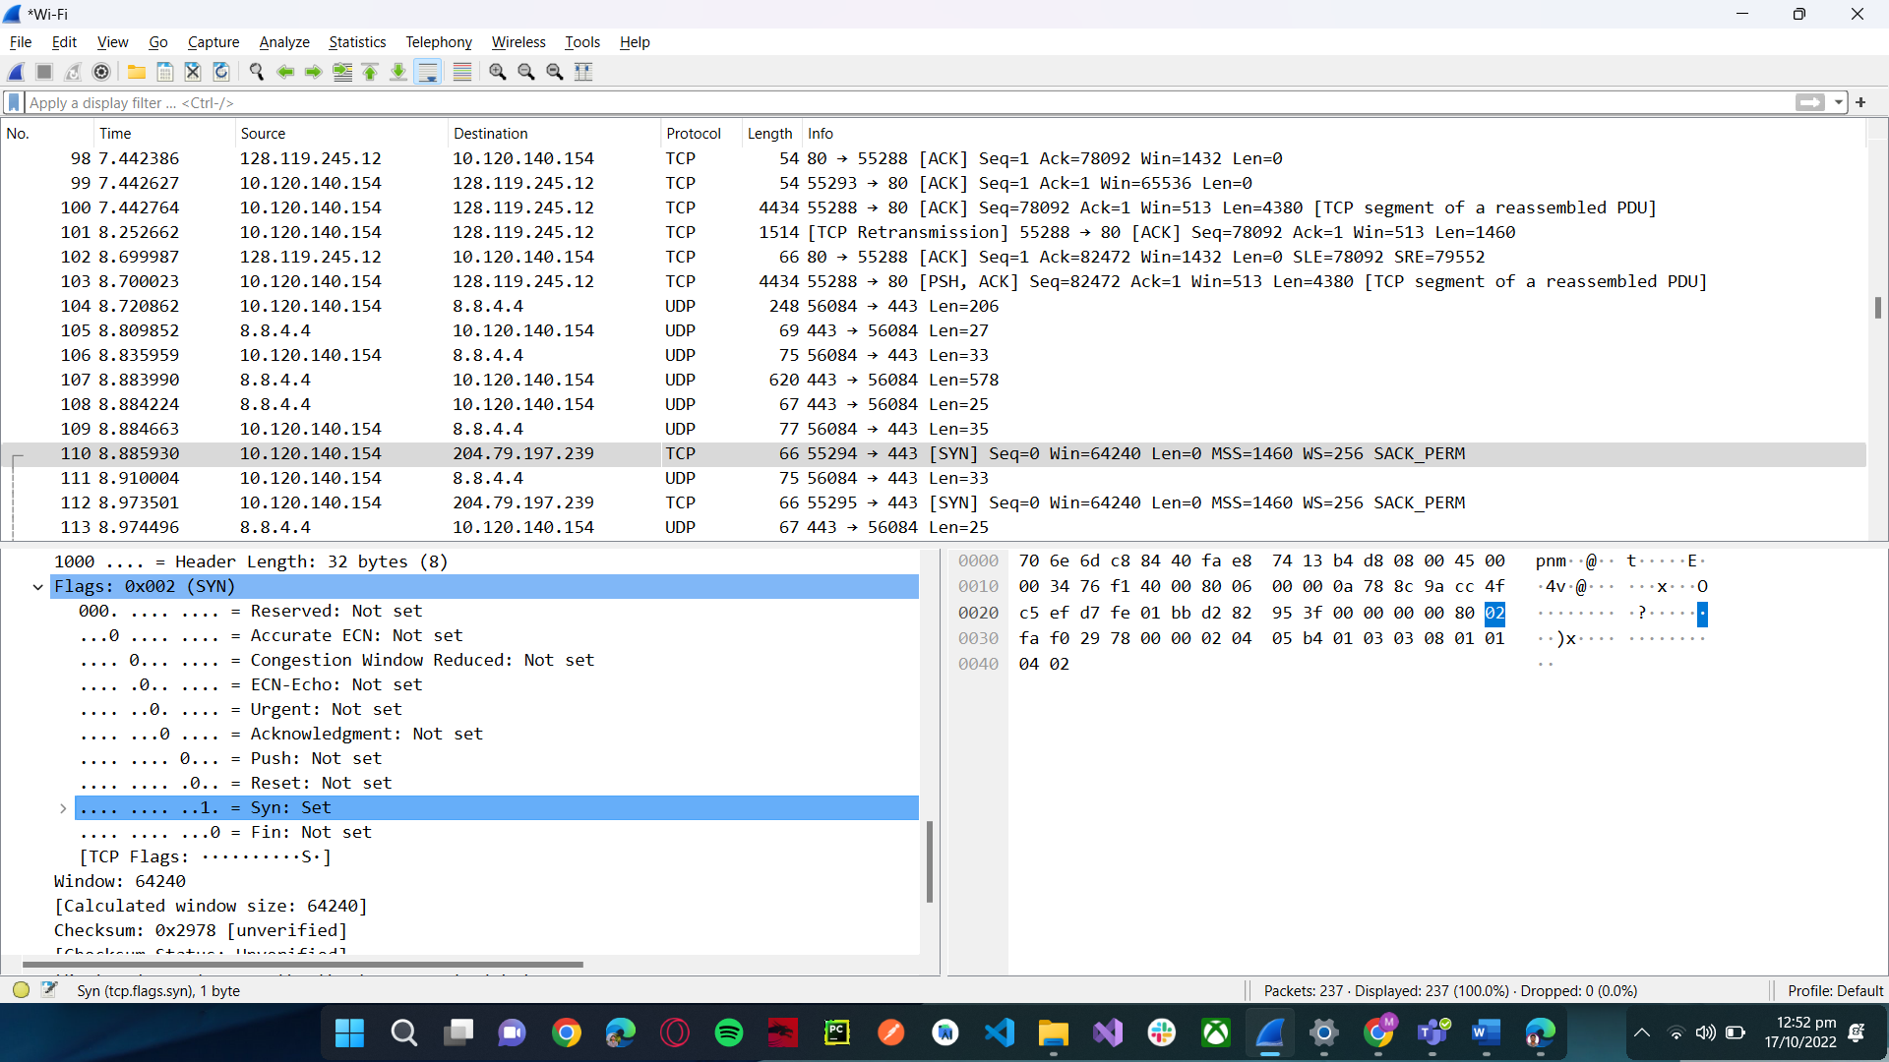

**Sequence Number: 0 (relative sequence number)**

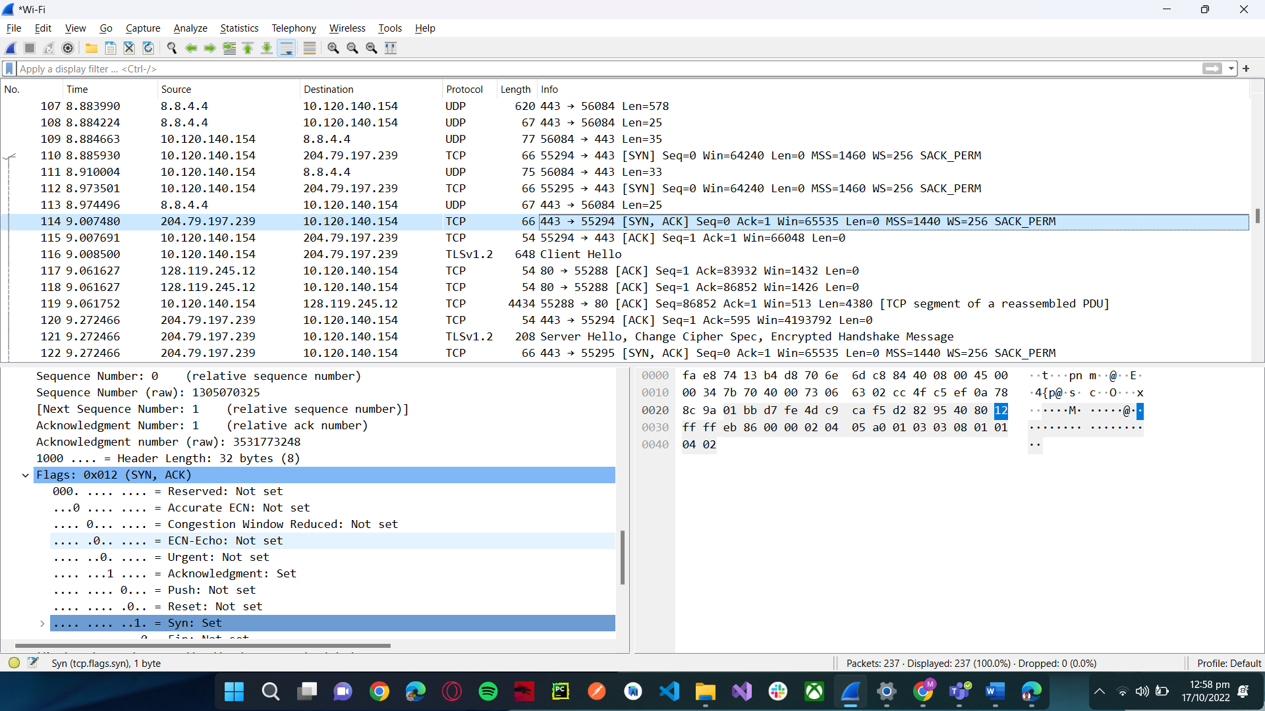

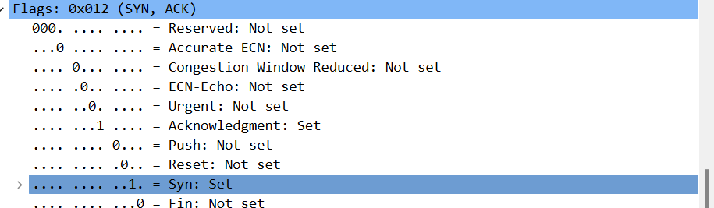

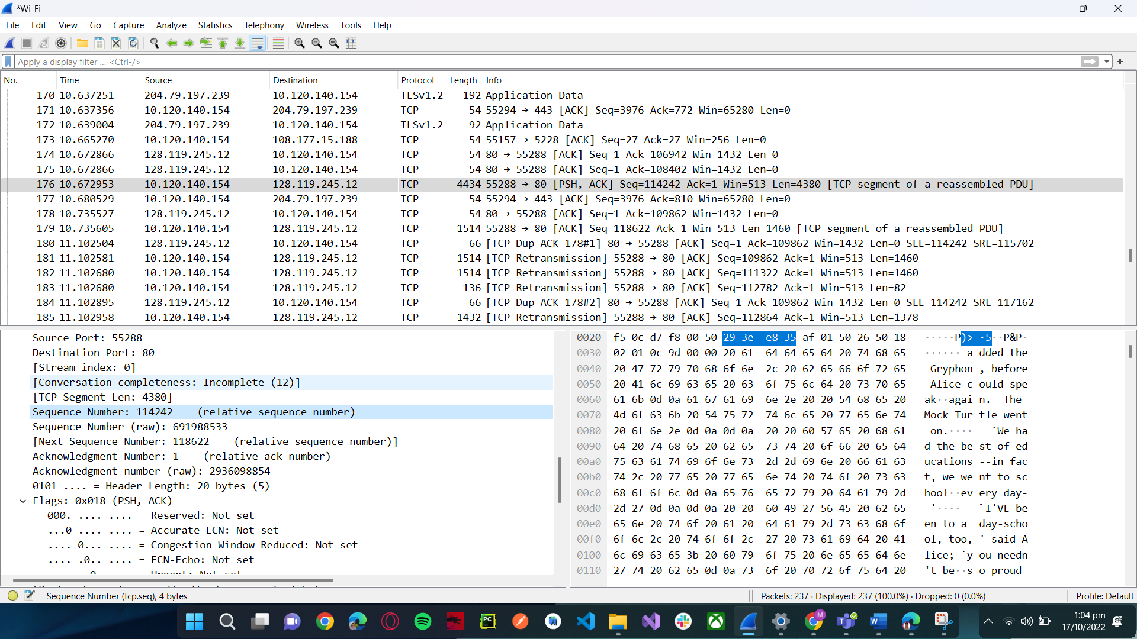

**Sequence Number: 114242 (relative sequence number)**

***Sequence Number: 0 (relative sequence number)***

***Sequence Number: 1 (relative sequence number)***

***[The RTT to ACK the segment was: 0.045887000 seconds]***

***Sequence Number: 712 (relative sequence number)***

***[Bytes sent since last PSH flag: 13140]***

***[The RTT to ACK the segment was: 0.000060000 seconds]***

***Sequence Number: 13852 (relative sequence number)***

***[Bytes sent since last PSH flag: 14600]***

***[The RTT to ACK the segment was: 0.411610000 seconds]***

***Sequence Number: 15312 (relative sequence number)***

***[The RTT to ACK the segment was: 1.243375000 seconds]***

***Sequence Number: 18232 (relative sequence number)***

***[Bytes sent since last PSH flag: 17520]***

***[The RTT to ACK the segment was: 1.215360000 seconds]***

1. Find in above answer
2. **Min: [Calculated window size: 354]**

**Max:** **[Calculated window size: 628]**

